Abstract
This project focuses on analyzing employee attendance in productivity to understand overall business performance. The company management has noticed that some employees are frequently absent from work, which raises serious concerns about its possible impact on overall productivity.This project aims to identify the key reasons behind this issue by analyzing different factors such as performance score, department, and attendance rate. The dataset includes important columns like employee id, department, sick leaves, performance score, job title, and attendance risk band. Using tools like MS Excel and Power Query, the data is cleaned, transformed, and structured properly for analysis. A dashboard is created to visually represent the insights in an easy-to-understand manner. Through this analysis, we identify which department employees causes high critical attendance risk for the productivity. The project also highlights how sick leave impact productivity. It provides meaningful insights that help management make better decisions. Overall, this project helps improve HR to identify the pattern using data-driven analysis.
Objective
The main objective of this project is to analyze the relationship between employee attendance and productivity in a company. It aims to identify which department employee generate high critical risk band and which department employee performs wells. Another important objective is to study how attendance affect overall productivity. The project also focuses on analyzing department-wise performance and department-wise attendance to understand which areas are performing well and which are not. By doing this, the project helps HR to make better business decisions based on data rather than assumptions. It also aims to improve productivity strategies and training the employee. The project helps in identifying critical risk employee in the department and suggests improvements. It ensures better resource allocation and planning. The ultimate goal is to increase overall productivity. Thus, the project serves as a decision-support system for business growth.
Problem Statement
The company is currently facing a major issue where employees are often take leaves but don’t know whether it affect the productivity. This indicates inefficiency in the HR analysis and raises concerns about productivity performance. Some products are sold in large quantities but generate very low profit, and in some cases, even negative profit. One of the main reasons could be heavy discounts given to customers. Another reason could be high product costs or poor pricing strategies. The existing reporting system only focuses on total sales and does not provide detailed insights into profit. Because of this, management is unable to identify which products or categories are performing well. There is also no clarity on regional performance differences. Without proper analysis, decision-making becomes difficult and ineffective. This project addresses these issues by providing detailed and structured analysis.
Proposed System
The proposed system is a Employee Attendance vs Productivity Analytics Dashboard developed using MS Excel and Power Query. This system provides a complete analysis of attendance rate, sick leaves, performance score, attendance risk band. It includes performance-level insights to identify which department employee needs a HR intervention immediately . It also provides Department-wise performance analysis to understand which department perform best. department-wise sick leaves analysis is included to identify which department employee has high sick leaves. The system allows users to filter data using slicers for better interaction. Visual charts and KPIs are used to represent data clearly. The dashboard is designed to be user-friendly and easy to understand. It helps management quickly identify problem areas and opportunities. The system supports data-driven decision making. Overall, it improves business efficiency and productivity.
Advantages
The proposed system offers many advantages for the management. It provides clear visibility into employee attendance and performance . Management can easily identify which employees are getting higher sick leaves which affects the productivty. The system helps in improving attendance strategies by providing accurate data insights. The dashboard is interactive and easy to use, which saves time compared to manual analysis. It supports faster and better decision-making. The system highlights key business trends and patterns. It reduces dependency on assumptions and guesswork. It improves overall business efficiency. Finally, it helps in increasing productivity and long-term growth.
Existing System
The existing system used by the company has no formal analysis linking employee absenteeism with the productivity levels, making it almost impossible for HR to identify whether attendance pattern is a major contributing factor to performance gaps across teams and departments. It does not provide insights into attendance at the productivity level. There is no department-wise sick leave or department-wise performance analysis available. The system does not consider the impact of employee absentees vs productivity. Reports generated are static and not interactive. HR relies on basic reports, which makes decision-making difficult. Important business insights are hidden due to lack of proper analysis. The system does not highlight employee attendance risk band. It also fails to identify high-performing department. Overall, the existing system is not efficient for modern data-driven business needs.

Disadvantages
The current system has several disadvantages that affect business performance. One major issue is the lack of detailed insights into productivity. Management cannot identify which employees are causing less productivity. performance strategies are often incorrect due to lack of data analysis. Attendance risk band are not properly controlled, leading to reduced performance margins. High risk band may still result in low productivity, which goes unnoticed. Manual analysis consumes a lot of time and effort. Reports are not user-friendly or interactive. Decision-making becomes difficult and unreliable. Business inefficiencies are not identified properly. Overall, these disadvantages negatively impact the company’s growth and productivity.
Modules Used
- Dataset from Kaggle (employee attendance data)
- Columns: Employee id, Department, Performance score, Sick leaves, Project handled, Attendance rate, Risk band
- Tool used: MS Excel 2024
- Data cleaning: Power Query
- Data processing: Error removal & transformation
- Analysis: Pivot Tables
- Visualization: Charts & Graphs
Methodology
The project follows a structured methodology to ensure accurate results. First, the dataset is collected from Kaggle. Then, the data is imported into Excel for processing. Data cleaning is performed using Power Query to handle missing and incorrect values. Data transformation is applied to prepare the dataset for analysis. Key performance indicators(KPI) such as performance score, attendance rate and sick leaves are created. Pivot tables are used to summarize and analyze the data. Charts and visualizations are created for better understanding. A dashboard is designed to display all insights in one place. Filters and slicers are added for user interaction. Finally, the dashboard is tested and finalized for use.
The project includes multiple levels of analysis to gain meaningful insights. Productivity-level analysis is performed to identify high-risk band and low-risk band employees per department. Department-wise sick leave analysis helps in understanding which department get high sick leaves. Department-wise performance score analysis is done to compare performance across different departments. Attendance risk band analysis is conducted to study its impact on employee productivity. It is observed that higher risk band often lead to lower performance. Certain departments contribute more to productivity despite lower attendance rate. Some department have less productivity but high attendance rate. These insights help HR and management make better decisions. Overall, the analysis provides a clear understanding of business performance.
Conclusion
The project successfully identifies the gap between employee attendance and performance in the business. It highlights the importance of analyzing productivity rather than just focusing on attendance pattern. Attendance risk band are found to be a major factor affecting performance. Some employees require training to improve margins. High-performing departments should be given more focus. Weak department employees need better strategies for improvement. The dashboard provides clear and actionable insights. It helps HR and management make informed and data-driven decisions. The project improves overall business strategy. In conclusion, this analysis supports sustainable business growth and productivity.
Result
The project achieves its objectives by providing detailed insights into business performance. It clearly identifies high risk band employee in department wise and low risk band employees. The analysis helps in improving productivity and training strategies. It also helps in controlling unnecessary sick leaves. Department wise sick leaves and department wise performance are clearly understood. The dashboard provides a user-friendly interface for analysis. Management can take quick and effective decisions using this tool. The project reduces business inefficiencies. It supports better planning and execution. Overall, the project contributes to improving productivity and business growth.
Future Improvement
The project can be further improved by adding advanced features. It can be integrated with Power BI for better visualization. Real-time data updates can be implemented. Machine learning models can be added for prediction. Training forecasting can help in future planning. Automation can reduce manual work. Advanced filters and drill-down features can be included. Mobile-friendly dashboards can be developed. More datasets can be integrated for deeper analysis. Predictive analytics can improve accuracy. These improvements will make the system more powerful and efficient.

Output
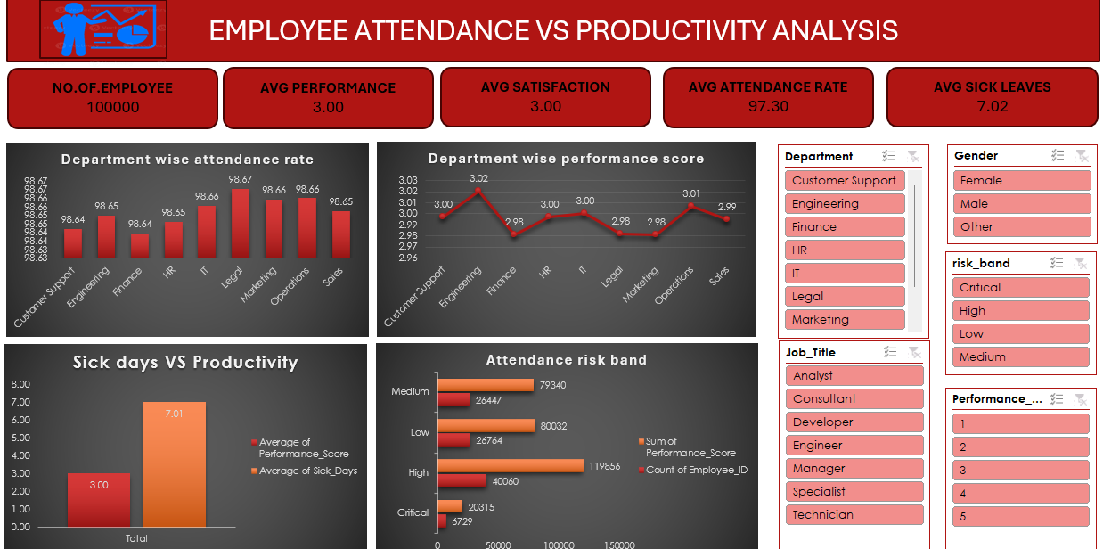
Reference
- a-study-on-hr-analytics-for-attendance-patterns-and-organizational-insights.
- Analysing the Impact of Employee Absenteeism on Productivity in Manufacturing Industries Analysing the Impact of Employee Absenteeism on Productivity in Manufacturing Industries.pdf
- Predictive Analytics in Attendance Systems for Employee Productivity and Accountability Predictive+Analytics+in+Attendance+Systems+for+Employee+Productivity+and+Accountability (1).pdf
- Examining the Relationship between Employee Attendance and Productivity Examining the Relationship between Employee Attendance and Productivity - FinClock

